INFORMATIONAL WAGE RATES BY OCCUPATION

OES Regions 2021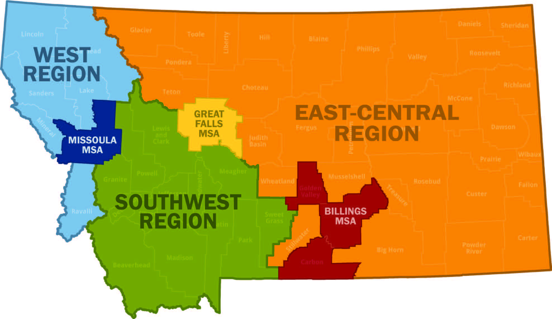
EAST-CENTRAL REGION
Big Horn County ! Blaine County ! Carter County Chouteau County ! Custer County ! Daniels County Dawson County ! Fallon County ! Fergus County ! Garfield County ! Glacier County ! Hill County
Judith Basin County ! Liberty County ! McCone County Mussellshell County ! Petroleum County Phillips County ! Pondera County ! Powder River County ! Prairie County ! Richland County
Roosevelt County ! Rosebud County ! Sheridan County ! Stillwater County ! Sweet Grass County Teton County ! Toole County ! Treasure County ! Valley County ! Wheatland County ! Wibaux County
SOUTHWEST REGION
Beaverhead County ! Broadwater County ! Deer Lodge County ! Gallatin County
Granite County ! Jefferson County ! Lewis & Clark County ! Madison County
Meagher County ! Park County ! Powell County ! Silver Bow County
WEST REGION
Flathead County ! Lake County ! Lincoln County ! Mineral County ! Ravalli County ! Sanders County
METROPOLITAN STATISTICAL AREAS (MSAs)
BILLINGS MSA:
Carbon County
Golden Valley County
Yellowstone County
GREAT FALLS MSA:
Cascade County
MISSOULA MSA:
Missoula County

